7.1 Integration of Static Code Analysis Tools with Jenkins

This section will guide you to:

* Integrate and configure static code analysis tools like *Checkstyle, Pmd, and FindBugs* with Jenkins

This guide has four subsections, namely:

7.1.1 Logging in to Jenkins

7.1.2 Installing Warnings Next Generation plugin

7.1.3 Creating a Maven job

7.1.4 Pushing code to GitHub repositories

**Note**: You should have *JDK 1.8 or more* and *Maven* installed and configured in your jenkins in order to proceed with this demo. In case you haven’t installed these, refer to demo 3.3 of lesson 3 to configure the same.

**Step 7.1.1:** Logging in to Jenkins

* Open the browser in your lab and navigate to **localhost:8081**
* Provide your username and password and click on **Login**

**Step 7.1.2:** Installing Warnings Next Generation plugin

* Navigate to *Manage Jenkins > Manage Plugins > Available*
* Search for ***Warnings Next Generation*** plugin

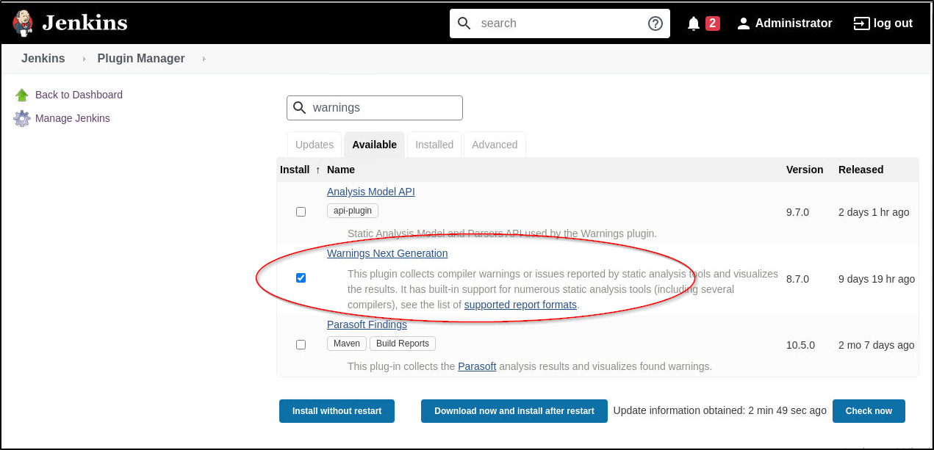

* Click on install without restart

**Step 7.1.3:** Creating a Maven job

* Go to Jenkins Dashboard -> New Item -> Choose a name for the Maven Project (ex: Warnings-plugin-example) and select *Maven Project* as the job type
* On Configure Page, set the following:

Under Source code management select *Git* and give the URL of your github repository that has a maven project

**Note**: You can use the simple-java-maven-app repository that you have created in the demo 3.4 of lesson 3.

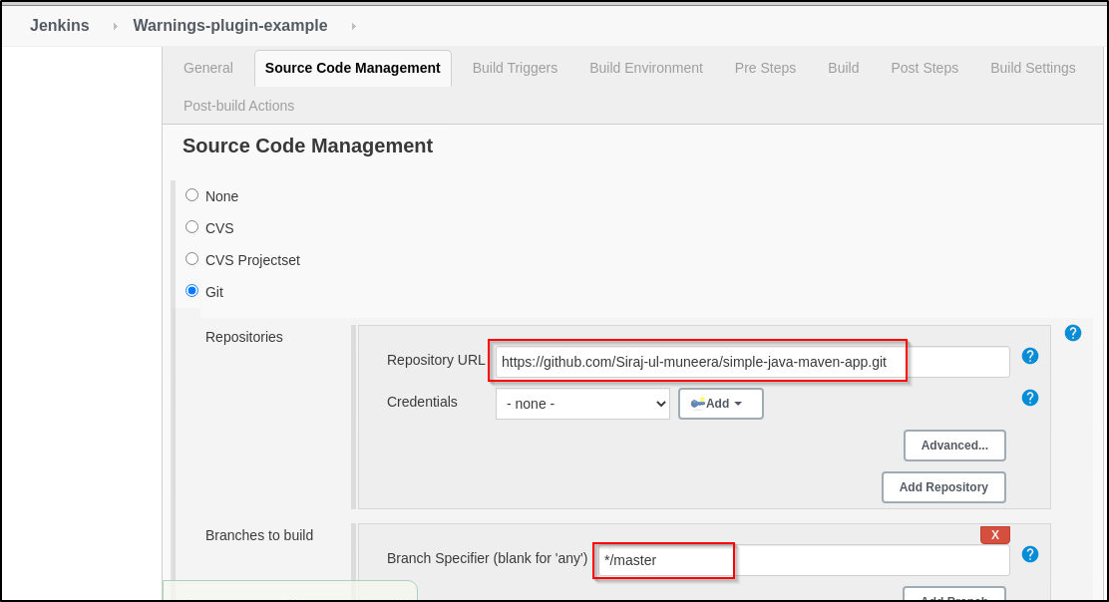

* Click on the *add a post build step* and select *invoke top level maven targets* from the list
* Select the maven version that you have configured in jenkins
* Specify the goals as: *clean install checkstyle:checkstyle pmd:pmd findbugs:findbugs*

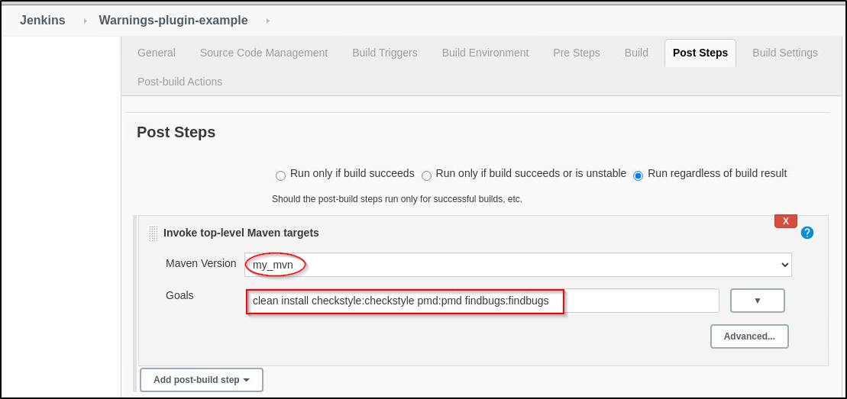

* Click on *post build actions*
* You will see an option **Record compiler warnings and static analysis results** in the drop down list if you have correctly installed the warnings next generation plugin. Select this option as shown below:

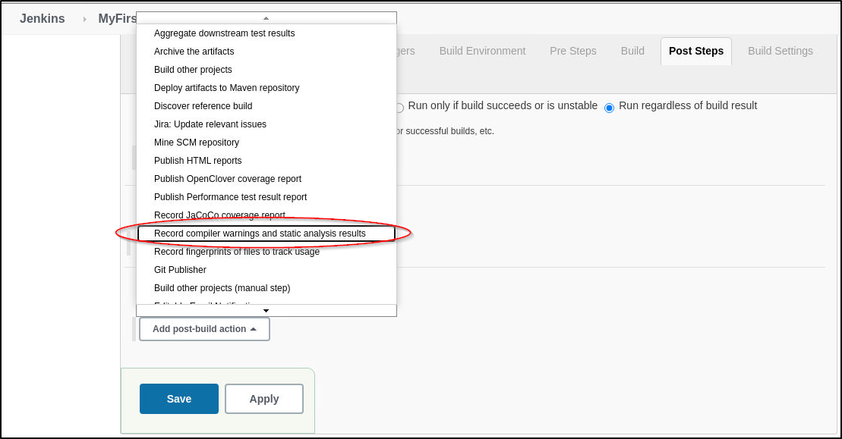

* Select the **CheckStyle** tool from the list of static analysis tools as shown below:

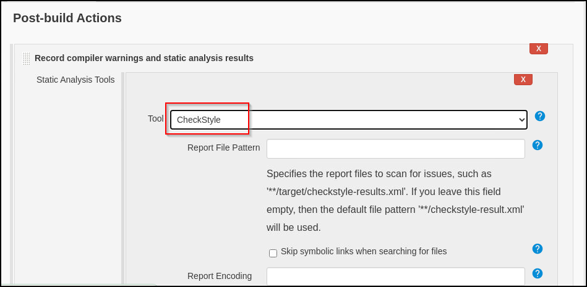

* Click on the**Add Tool** button as shown below:

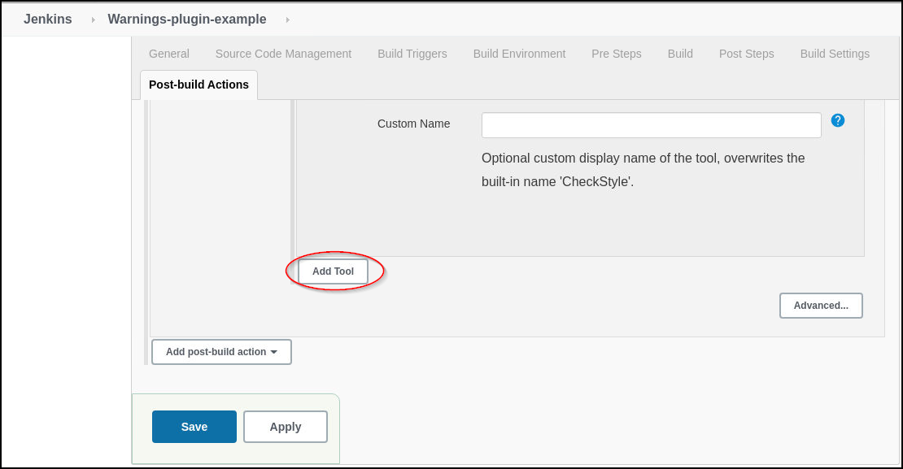

* Add **Pmd and Findbugs**tools from the list one by one by clicking on the **Add Tool** button

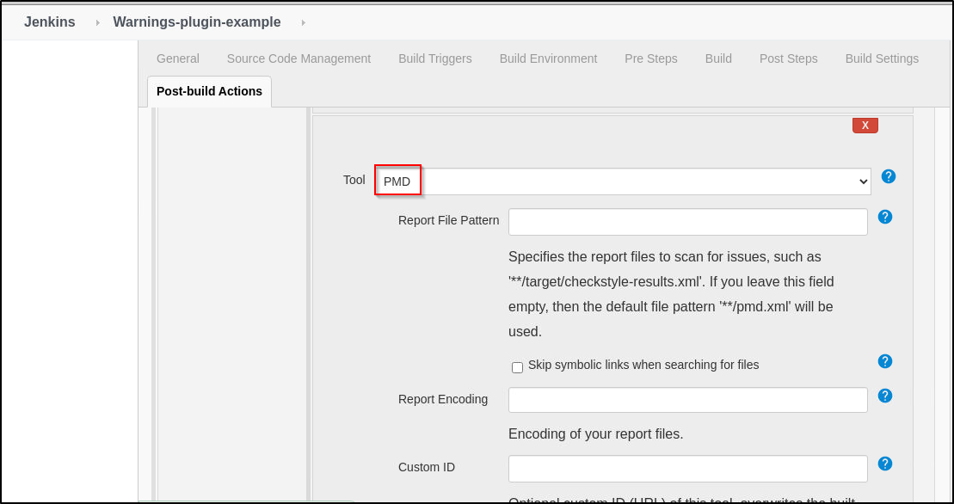

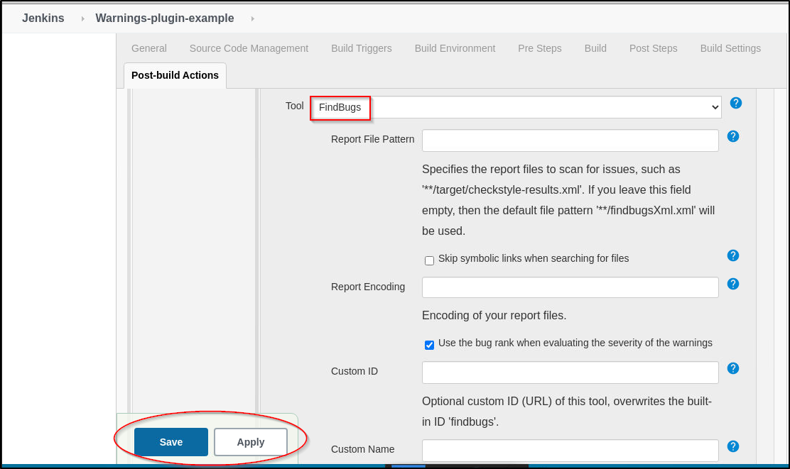

* Click on **apply and save**
* Build the job
* Once the build is complete, from your console output click on the build number. You can see all the warnings from checkstyle, pmd, and findbugs listed as shown below:

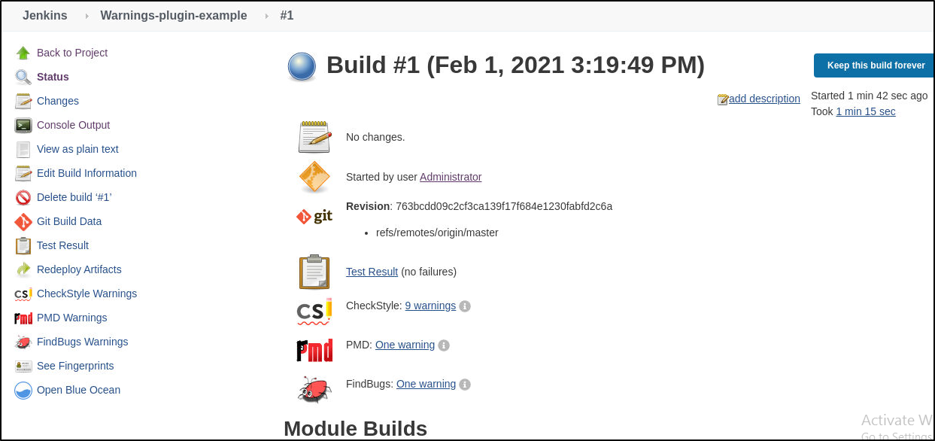

* You can click on each of these warnings to know about them in detail

